THE NEXT INTERCONTINENTAL TEAM MEETING

In 2010, the Intercontinental Team meeting will take place in the same diocesan house in Porto (Portugal), who is hosting us for the Committee one week prior to the committee, allowing for the exclusive participation of the members of the Intercontinental Team (Core Team and Continental Coordinators).
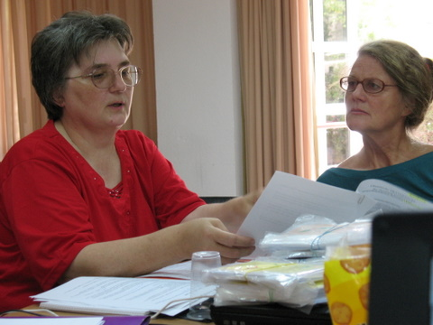
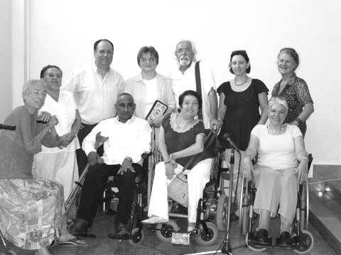
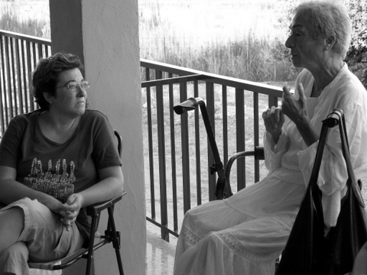

The Intercontinental Team meeting will take place from July 27th, the day of arrival and set-up, to July 31st, 2010.
After the Intercontinental Committee, we will hold a brief meeting to review the Committee and the implementation of the planned activities.
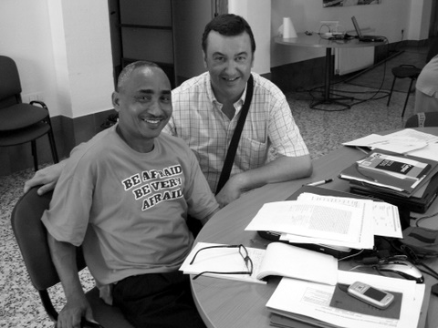
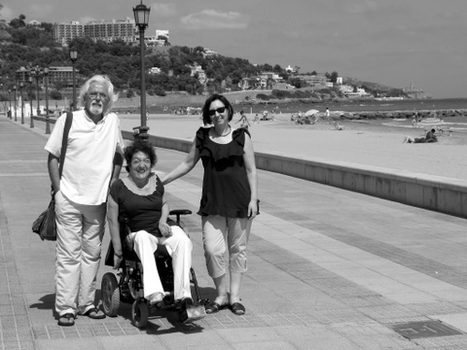
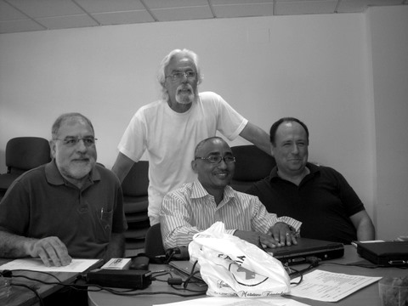
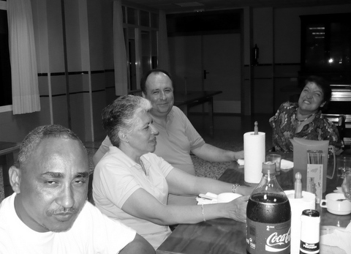

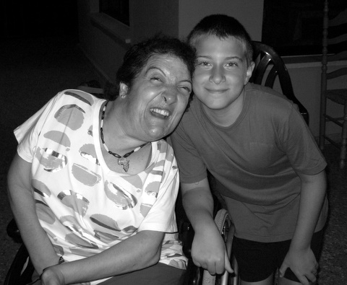
Photos of the Intercontinental Team Meeting. August 2009.

