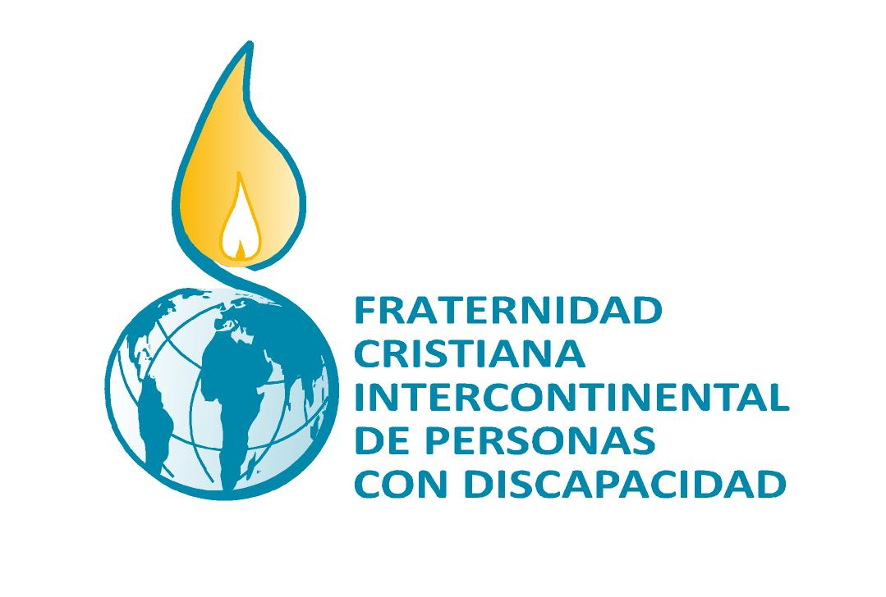 | EQUIPO NÚCLEO INTERCONTINENTAL  Avda. Los Pinos, 242  12100 Grao de Castellón - ESPAÑA  www.fratinter.org  fratinter@gmail.com

PRESS RELEASE PRECEDING THE INTERNATIONAL DAY FOR PERSONS WITH DISABILITIES on December 3, 2011

This year, the United Nations has suggested to those of us living and working with a disability, a similar theme for this day: “United for a better world for all: including persons with disabilities in terms of development" *.

The core team of the Intercontinental Christian Fraternity of People with Disabilities would like to join in this celebration by way of this press release. We would like to emphasize the call of duty, based on the Millennium Goals** and its subsections, which our Fraternity has contributed significantly to since its beginnings. Through our work, we have become aware of the urgency of this work in today’s world including:

- Continuing support of the visibility and progress of the issues surrounding people with disabilities in terms of human development. We approach this work not only as those who stand to benefit, but as active participants. We coordinate our efforts, create networks, and share our experiences and stories.
- In keeping with the Millennium Goals to eradicate poverty, our aim is to help those who tend to be at the center of this problem; women and children. As a matter of fact, women and children make up the vast majority of active members and leaders of our movement.
- Working towards accessibility and elimination of barriers, both themes which have been the catalyst and commitment for many of our members; goals which they would like to see realized in society at large.
- Providing information on the impacts and meeting the needs and challenges posed by disabilities in today’s world; through reflection and the creation of core teams.

From the perspective of our humble contribution, we value and acknowledge the fact that increased awareness of human rights and the fight for justice and liberty are becoming more prominent in the universal consciousness. Two good examples of this are the World Programme of Action concerning Disabled Persons of 1982, and the Convention on the Rights of Persons with Disabilities, adopted by the United Nations in 2006. However, this “society by and for all” promoted by these movements, must be reflected in practical terms by the full participation of persons with disabilities within social and development contexts. In other words, living conditions for all people must be improved, including those of the most disadvantaged populations.
In the first part of his encyclical “Pacem in terris”, Juan XXIII, after having considered that which was set forth in the Universal Declaration of Human Rights, added to it the notion of “responsibility.” It is only when we realize that another person’s rights are our responsibility, will we be living up to the spirit and profound sense of purpose of the Universal Declaration. This swap of rights for responsibility creates a new dynamic in which all people are implicated. As such, we believe that leaving no individual or group out of the equation is the best (if not the only) driving force for human development and social change.

Because of this, and based on our work and commitment, and the possibilities that present themselves:
- We urge governments to uphold the Convention for the Rights of Persons with Disabilities and adopt its regulations so that their full participation in all social, economic and political issues becomes a reality.
- The full participation of all people wanting to do so should be facilitated, so that each person takes responsibility onto himself, and recognizes the contributions of all individuals within a context of diversity. Along these lines, the Vatican II recognized the right of all individuals to be themselves, and that “God wanted people to be able to make their own decisions.” (Gaudium et spes, 17).

Given our belief in the “God of Life” who wants a full life for all individuals, and who is the protector of those living in the most unfavorable conditions, we also encourage the Christian Fraternity of People with Disabilities, along with the other associations in our group, to work toward the betterment of society, the acceptance of human diversity, and the potential for personal development, including that of persons with disabilities.

* http://www.un.org/disabilities/index.asp
** http://www.un.org/millenniumgoals/

