SOLIDARITY: fraternal community
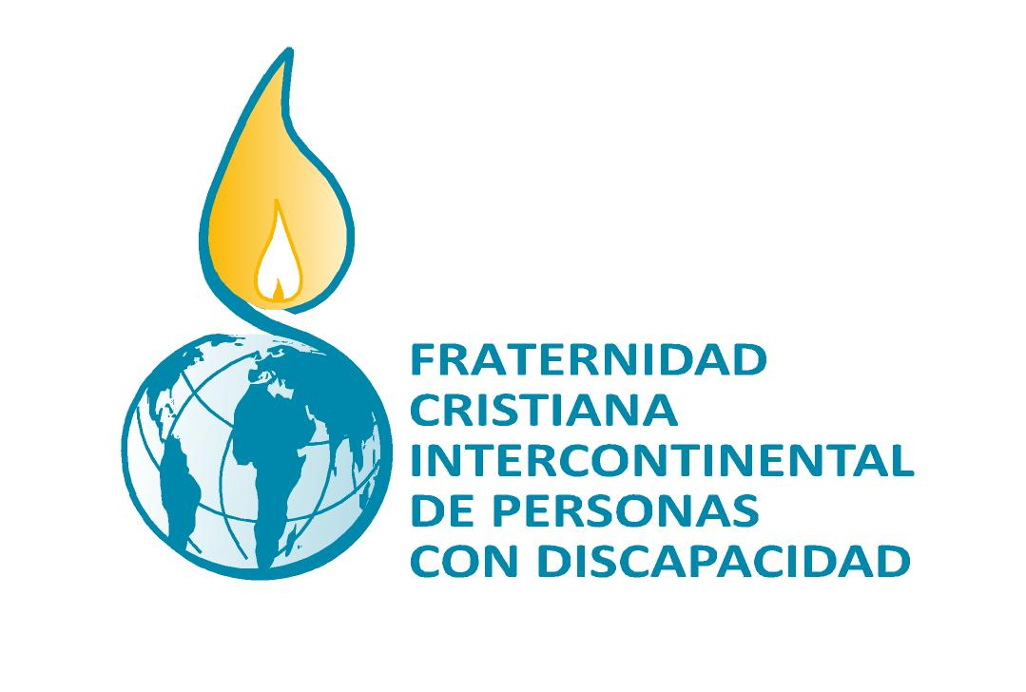
of goods and values

"... that all of them may be one, Father, just as you are in me
and I am in you. May they also be in us… "John, 17:21

GUIDELINES FOR THE WORK IN TEAMS

The Intercontinental Christian Fraternity of People with Disabilities is a movement caring for the complete development, the human and spiritual formation of those people who are part of it, and of those people who engage and cultivate contact with the movement.

In order to carry out this work our ideology tells us that we promote the development of fraternal life with an open mind and proclaiming the gospel. Moreover, we want to pay more attention to the peoples´ lives and to the Word of God, which are the sources of our transforming action.

Announcing the Good News enables a more humane and fraternal life. The fraternity, however, must not forget in their action and lifestyle to grow in the community of goods AND VALUES. This means that we must grow knowing how to give and share what we are and have, as an individual and as a group, for the benefit of our entire movement.

We believe that each of us has skills and values ​​that can be contributed to the community. This is especially important for the Fraternity´s work to continue announcing their message and prophetic accusation among people with disabilities. No one must be excluded from the solidarity movement.

Our goal is to change human society. The good deeds of the individual are therefore not enough. Neither doing good from top to down, nor giving alms or holding charity events. We must create a community where there is neither yours nor mine and where the joy of sharing is the most sincere bond of brotherhood and togetherness.

Fraternity members must increasingly experience that the true self-realization is achieved when focusing less on your own person. Anyone who has ever experienced love understands better that the more you love the other person, the more authentic you are. In a similar way we can say that the more we behave in a socially responsible manner, the happier we will be.

If we want the community to be provided good deeds and values, we must do so on the basis of being sincere when sharing with our brothers and sisters. We are individuals and a group not only that other people share with us but rather that we as individuals and a group contribute to it being there for others.

These ideas prompted the Intercontinental Team to openly announce in the Intercontinental Committee 2010, that it is the responsibility of the team to promote unity and solidarity among the members of the fraternity from all continents.

There was a report on this subject in the Committee of Oporto (Portugal), 2010, which was very well adopted by all participants. This report "Sharing what we have and are" is openly accessible to expand ideas and to help others in their reflection.

Moreover, all teams at the base and all the responsible people should work on this subject for the next committee 2014. For this purpose the following objectives should be considered. To fulfill the objectives some evangelical texts and a questionnaire are provided to reflect on the objectives.

OBJECTIVES

- TO Feel the unity of the whole fraternity. Do not linger in the local environments but open yourself to other realities and the world. You should not only work for your own community. You should be aware that we are part of a larger family in the world.

- TO DISCOVER THE DIVERSITY OF EACH PERSON AND THE FRATERNAL GROUP WE BELONG TO TO BECOME AWARE THAT WE ALL CAN AND MUST SHARE. We all have skills and values to provide to the whole community.

- TO EMPHASIZE THAT AMONG THE VALUES WE SHARE ARE ALSO THE FOLLOWING:
- To share our time as we are willing to assume responsibilities in all teams of the Fraternity.
- To share material and economic resources as it contributes to its success.

- TO UNDERSTAND THAT ALL MUST CONTRIBUTE TO THE FRATERNITIE´S PRESERVATION AND SUCCESS AND NOT ONLY THE RESPONSIBLE TEAMS. It starts with each individual and must affect everybody in the same way.

- TO RAISE AWARENESS THAT OUR SOLIDARITY REQUIRES A COORDINATED AND SUSTAINABLE ACTION OF THE WHOLE MOVEMENT. Our resources come from our own efforts of the teams and the fraternity members. It is our objective to make it accessible to the whole community. (Knowledge is good, common knowledge is better, says Father François). We should always comply with this and not only when the responsible persons expect us to do so or when there is an urgent need for it.

In terms of economic resources it is also important to share for the benefit of the Fraternity, especially having in mind the Intercontinental Committee of 2014. It is important that we always offer and share our skills and values ​​and that we motivate us in all countries and in all continents to pave the way for the fraternal unity.


TEXTS

The parable of the talents, Matthew 25:14-27

The sending of the disciples, Luk 9: 2-6

QUESTIONNAIRE

- What kinds of values ​​and skills do you discover in you and your fraternity?
- With regard to the texts (The parable of the talents, the sending of the 12 disciples): To what kind of action do they drive you personally and your group with the objective to grow in solidarity?
- Once the groups and my personal values have been discovered – how can they be transformed for the benefit and the development of the entire fraternity? Try to achieve a compromise. Consider the objectives mentioned above.

