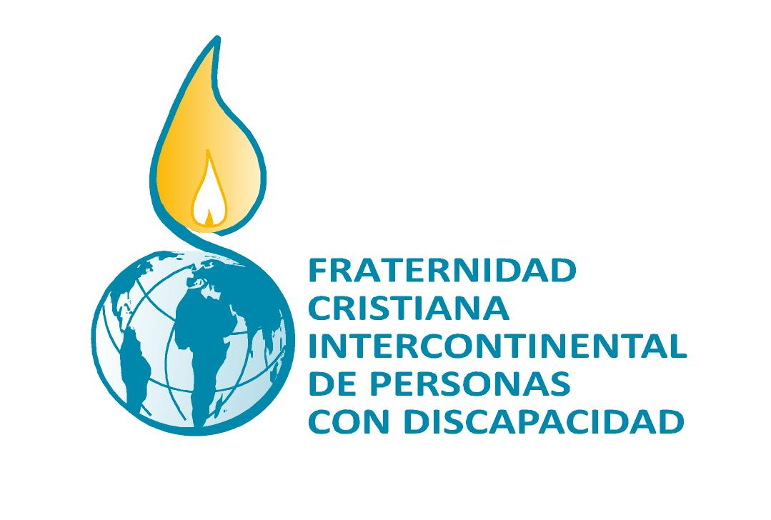 | EQUIPO NÚCLEO INTERCONTINENTAL  Avda. Los Pinos, 242  12100 Grao de Castellón - ESPAÑA  Tel. ++34 964 28 29 92  fratinter@gmail.com  www.fratinter.org

3 December 2013 “The International Day of People with Disabilities”

PRESS RELEASE OF THE INTERCONTINENTAL CORE TEAM

It is time to break barriers and open doors

As in previous years we would like to take up the United Nation´s topic for the International Day of People with Disabilities “Break barriers, open doors: for an inclusive society for all”.
As members of the Fraternity we witness at first hand that persons with disabilites still face physical, social, economic and attitudinal barriers that exclude us from participating fully and effectively as equal members of society. Thus, we lack equal access to basic resources such as education, employment, healthcare and social and legal support systems which leads to more poverty, a reduced quality of life and a higher rate of mortality.
We therefore denounce together with many other collective members that disability has remained largely invisible in the development policies and even more in its processes.
From our identity as believers we would like to adapt the United Nation´s slogan “Open doors”. This reminds us of the important parable in the Gospel of St. John 10, 1-17, that everyone who shares our faith and hope is encouraged to read.
In these lines entering by the door means having a good will and intentions. Everyone who does not enter by the door is a thief and a robber (1). In the world of disability we currently have to deal with dishonest people who do not enter by the door. In fact, they become rich at the expense of the weak adopting mechanisms to deny them what everyone has a right to: dignity and fullness of life.
Open doors means the effort to give disabled people back what they have been denied and what they are still denied: their dignity and chances and opportunities in life. This is our Fraternity´s mission.
Let us open doors together. Everyone who decides to go in and out by the door knows and is known, says John (4-5). Hears and is heard, has capacity for dialogue. Fruit of this dialogue is liberation in order to change our lives: we go out by the door to find an open place and not new restrictions and dependencies denying us to grow.
The Gospel says that Jesus is the door for us. Therefore we should work for the peoples´ lives and for the fullness of life without barriers. The Good News gives us hope and brings us the knowledge that the efforts for the benefit of others will not be in vain (9).
Like Jesus we want to work selflessly. Not like the salaried employee who resigns from work when he sees a threat or adversity coming. But like someone who knows that he gives his life and lays it down for daily activities (15).
The Intercontinental Core Team would like to encourage you to open doors in order to reach those people who do not take part in life. Especially those people who have been denied its participation. We must not forget the fact that we are all part of a large family and that we all share God´s love.

